AWS Practical work

1. S3 (Amazon S3 (Simple Storage Service) is a scalable cloud storage service that lets you store and retrieve any amount of data securely from anywhere.)

Here we can create the bucket to store the folders and files on the cloud.

B) Here I give the name to the bucket and then create it.

C) Successfully created the bucket

D) It is the interface where we can upload the documents on AWS.

2. EC2(Amazon EC2 (Elastic Compute Cloud) is a web service that provides resizable virtual servers in the cloud for running applications.)

A) First I created the instance

B) Interface of instance

C) Then connect it to the instance.

D) EC2 Instance Terminal Access

E) Then I run simple python scripts

F) Hosted a web page at this instance

G) This is the page I have created and hosted over the AWS

3.Lambda Function (AWS Lambda is a serverless compute service that runs your code automatically in response to events without managing servers.)

1. Creating the lambda function

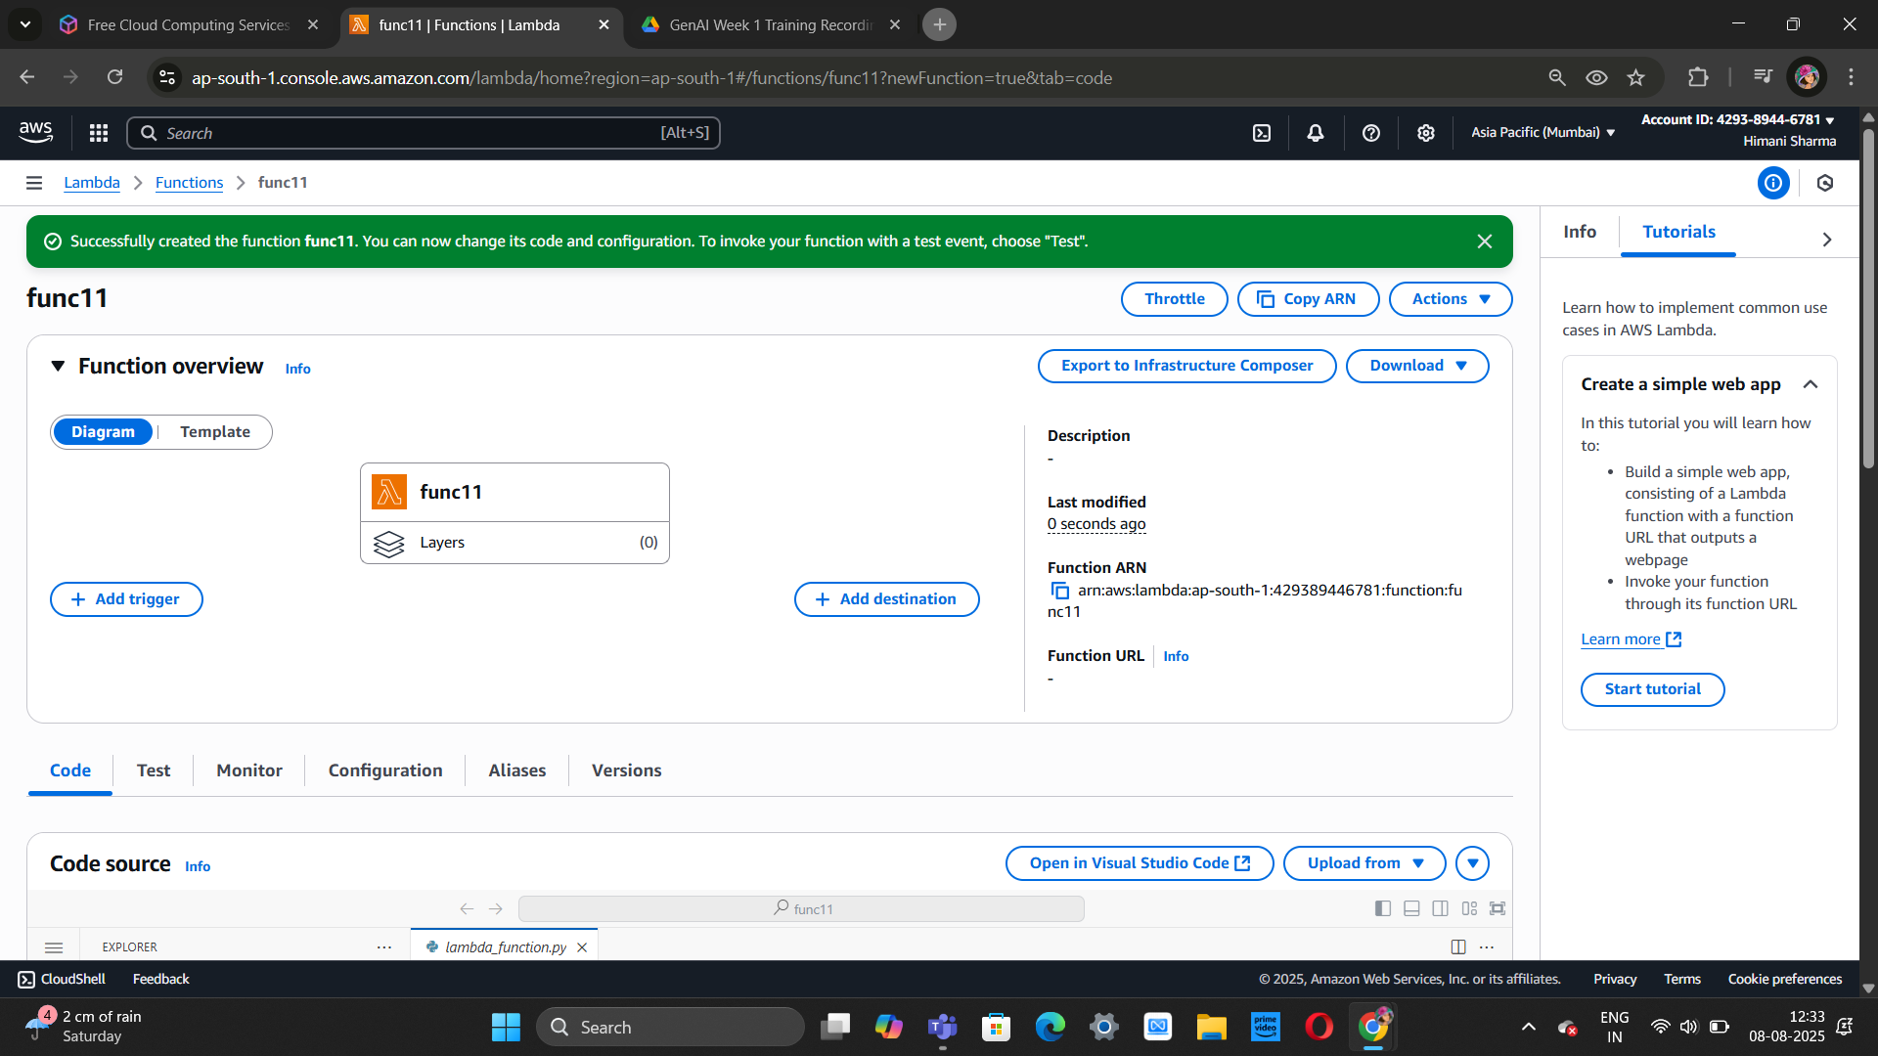

1. AWS Lambda Function for To-Do List API

1. AWS Lambda Function Integrated with API Gateway to Display To-Do List as a Webpage.

[**https://i6cjszj5h0.execute-api.ap-south-1.amazonaws.com/default/todoListFunction**](https://i6cjszj5h0.execute-api.ap-south-1.amazonaws.com/default/todoListFunction)